 

School of Computer Science & Software Engineering

Bachelor of Computer Science (Digital Systems Security)

CSCI321 - Project

**Final User Manual**

Group: FYP-25-S2-14P

Zikry Bin Affendi 8380338 zba505@uowmail.edu.au

Tan Zhi Qin 8259240 zqt072@uowmail.edu.au

Muhammad Hannan Azman 8220852 mha986@uowmail.edu.au

Wong Xin Yang 8497035 xyw523@uowmail.edu.au

Ernest Yeo Jun Long 8535139 ejly205@uowmail.edu.au

Supervisor: Tian Sion Hui

Assessor: Japit Sionggo

Table of contents

Table of contents........................................................................................................................2

1. Introduction............................................................................................................................3

2. User Activity Diagram. ...........................................................................................................4

3. Overview

2.1 Home ………………………………………………………………………………………5

2.2 History of QR Codes ……………………………………………………………………..6

2.3 Scan QR Code

2.3.1 Scanning using your phone camera …………………………………………7

2.3.2 Scanning a QR Code from the Gallery……….………………………………8

2.3.3 Understanding your scan results ……………………………………………9-12

2.4 Settings …………………………………………………………………………………….13

1. Introduction

The increasing reliance on QR codes for tasks such as accessing online content and making transactions has brought an increase in security challenges. Cybercriminals tend to leverage on these to carry out harmful attacks such as phishing, malware distribution and data theft. These vulnerabilities highlight to us the utmost need for a secure way to handle QR interaction.

**What is SafeQR?**

SafeQR is your essential QR Code Scanner which is designed to protect you and the people around you from these hidden digital threats. Our android application provides a robust and intelligent solution for scanning QR codes and immediately accessing the safety of the links that are embedded to the QRs.

Our application, SafeQR, adopts a dual layer detection approach which will ensure every QR code scanned is thoroughly vetted. This also ensures you receive accurate and actionable alerts, making you to make better and confident decisions with every QR scanned. This means that the dual-layer approach combines the speed of a local database with the comprehensive coverage of a global security network, ensuring that the threats are detected quickly and accurately.

With SafeQR, your safety is our paramount.

2. User Activity Diagram

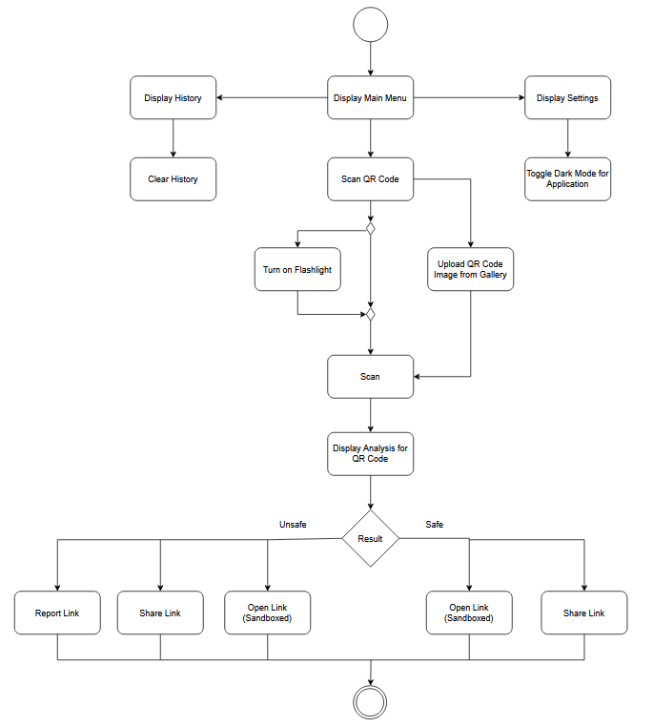

2. Overview

2.1 Home Page

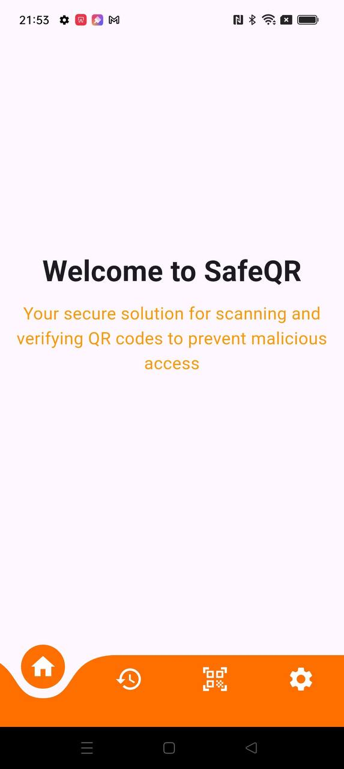

When you first enter our SafeQR application, you will be greeted by a clean and welcoming space, which is designed to get you straight into action. As you look around at the bottom, you can view different tabs on the application. This brings you to the various functions of the application.

2.2 Scan History

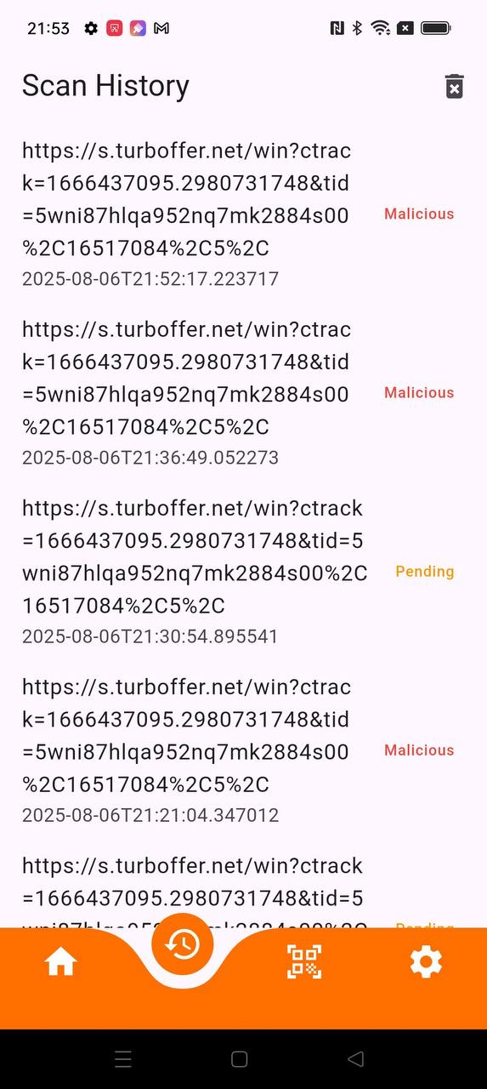

The Scan History page keeps track of the past QR codes that have been saved by the user, as well as the status of the scan. Information stored includes the link, the date and time of scan, as well as the results of the scan. Users can also clear the entire list of past QR codes scanned with a click of a button.

2.3 Scan QR Code

2.3.1 Scanning using your phone camera

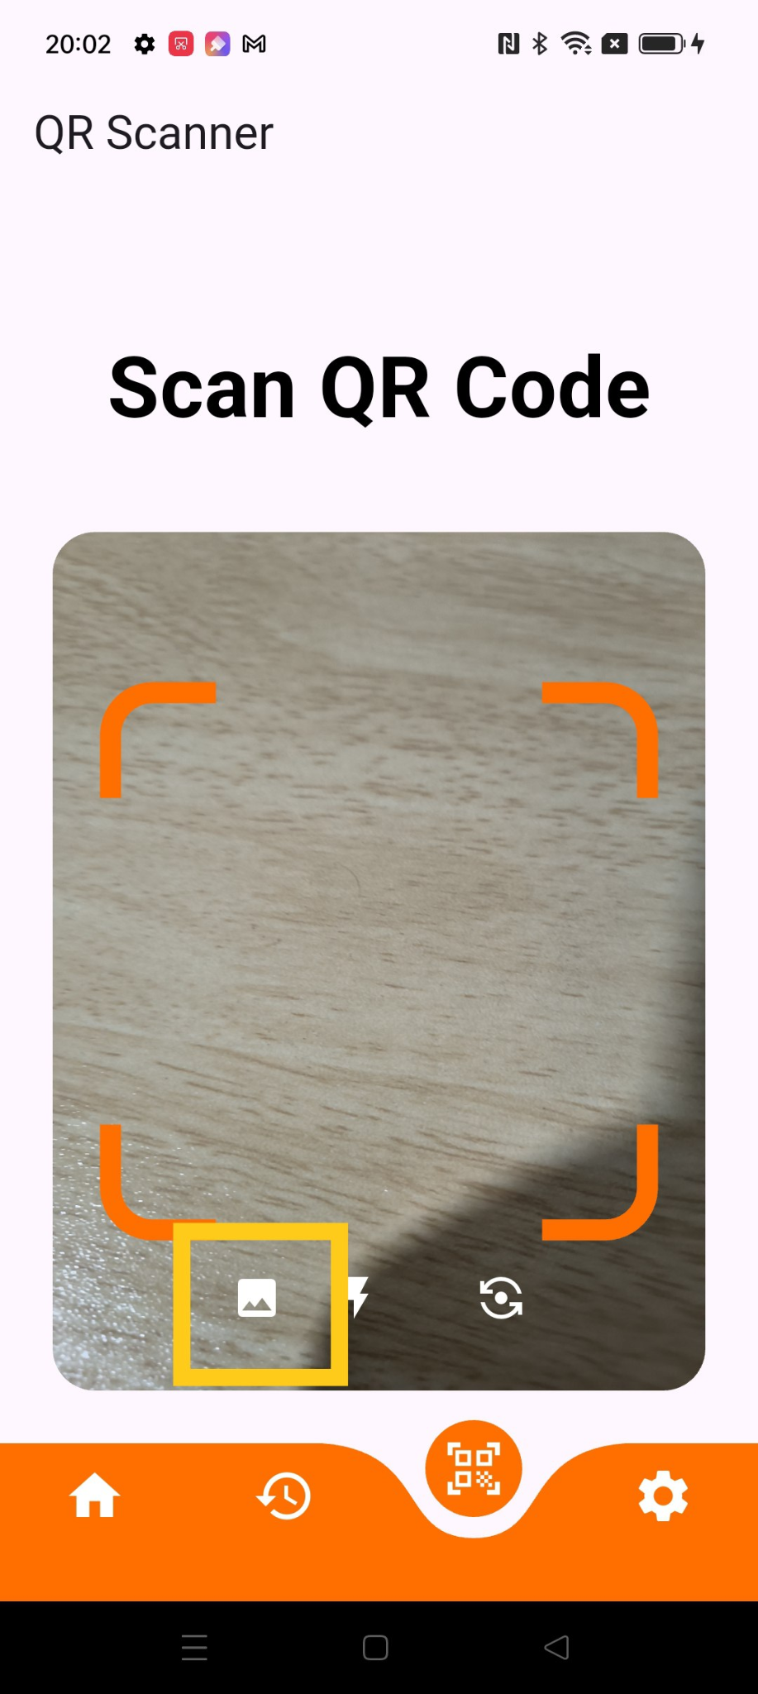

SafeQR is well equipped with the most practical feature to ensure seamless QR code scanning across various conditions. Our tools are well integrated with your device’s in-built camera directly into the scanning interface for immediate access. To enable the flashlight on your device, simply click the “bolt” logo and your device’s flashlight will work without any delay. This illuminates the QR code for improved visibility and scanning accuracy in low light conditions. Apart from that, our application provides a camera switching function that allows you to even scan QR codes with your devices’ front camera. This comes in handy when your back camera is obstructed or malfunctioning. With just a click on the “Camera Flip” logo, you can simply scan the QR code with the front camera.

2.3.2 Scanning a QR Code from the Gallery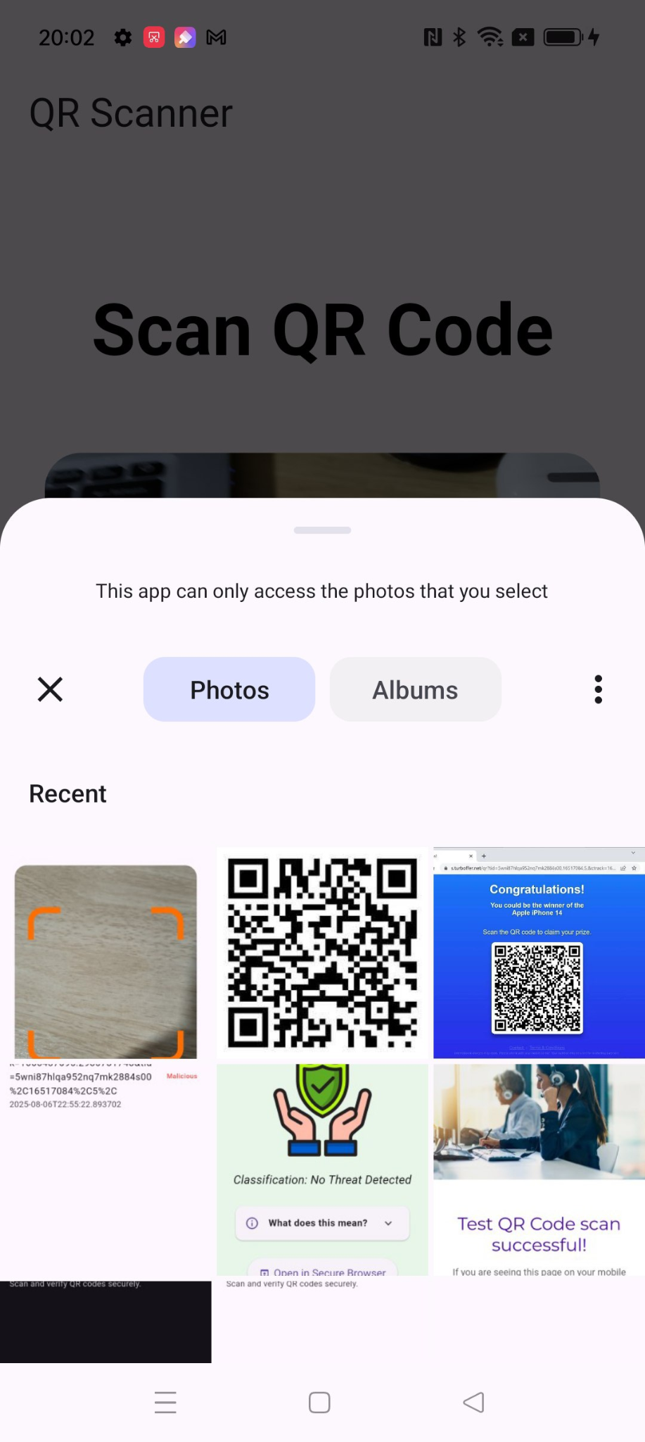

Additionally, SafeQR offers a Photo Library Scan feature which allows users to get their QR codes scanned by uploading the photo from their device’s photo library. This is especially useful if you receive QR codes via messaging apps or other communicating platforms and wish to scan them without the need to print or even display the QR code on another device.

2.3.3 Understanding your scan results

SafeQR will automatically navigate you to the Results page after every scan of QR code. This will then provide you with key information such as the integrity of the QR code, giving you a clear verdict.

**RESULT: SAFE**

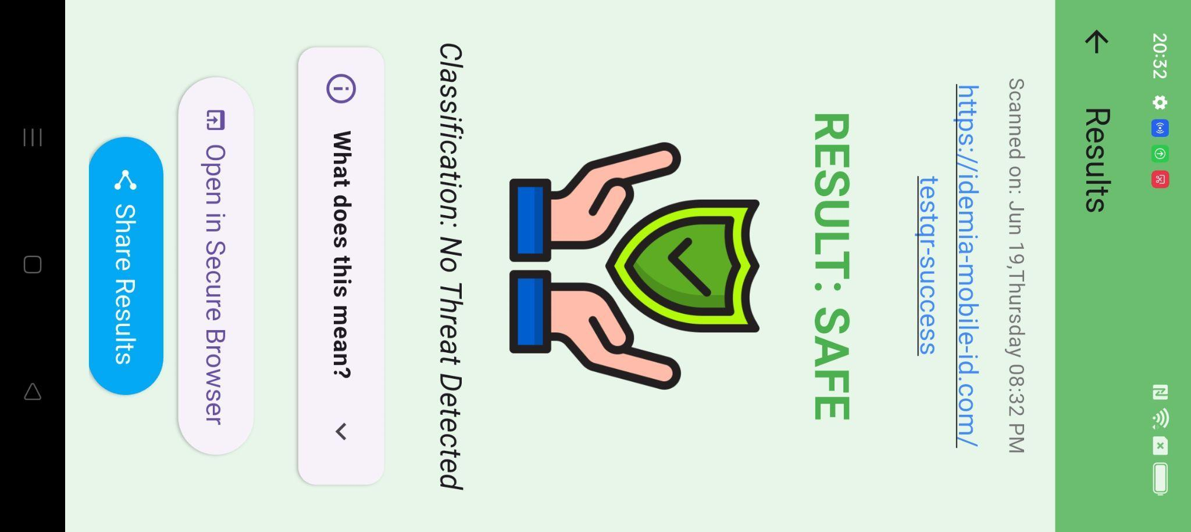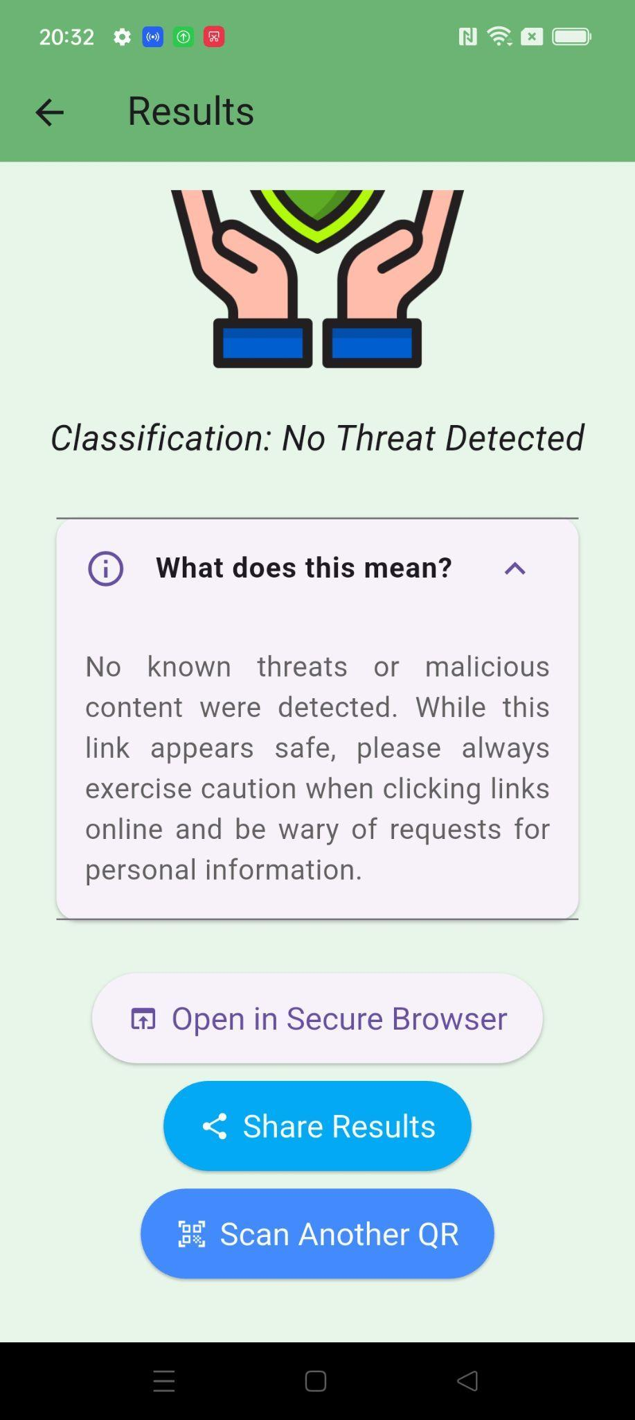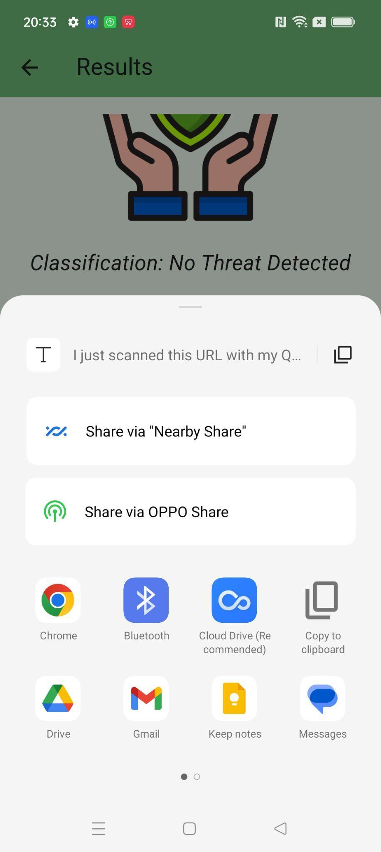

If SafeQR detected no threats from the QR code, a green “RESULT: SAFE” would appear. A short description explaining what the result means would also be included to educate users on the meaning behind the safe scan. Users can also open the link in a safe environment within the application by simply pressing the “Open in the Secure Browser”. This feature is important as opening it in a safe environment without affecting their devices to potential threats. This provides enhanced security for all. Users can also share results from the scans to others or even choose the option to open it in an external browser once they decide to do so.

**RESULT: UNSAFE**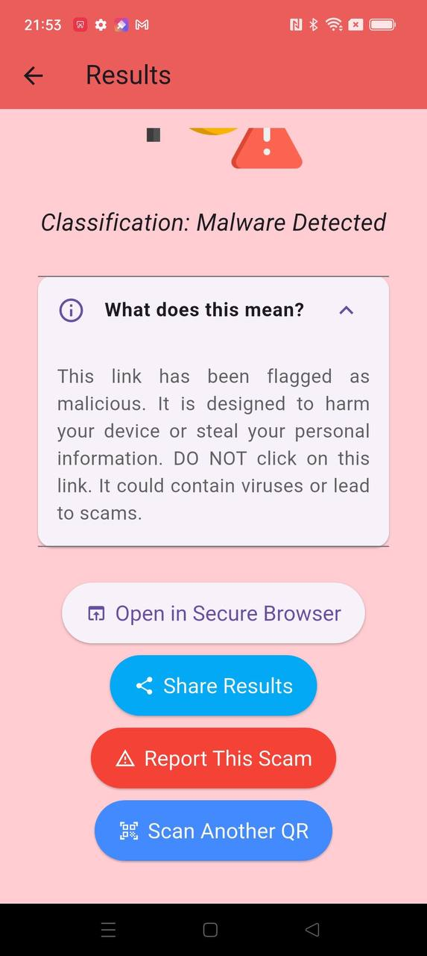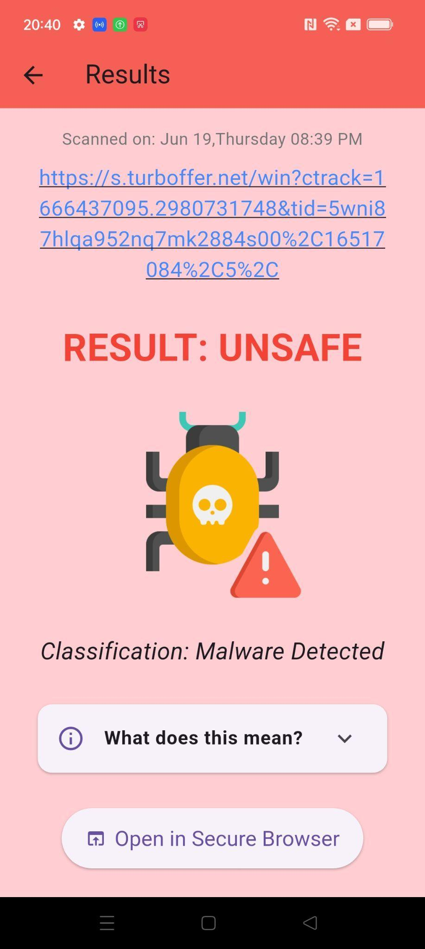

SafeQR warns the users that the link has been flagged as potentially harmful by our application, indicating that the contents from the link may have malicious contents. SafeQR will also provide suggestions such as to not click or open the link if it is being flagged as malicious. Similar to the “RESULTS: SAFE”, a brief description will also be sure if users are unsure of the meaning behind each scan result. Additionally, when a QR code is classified under Unsafe, our application offers a one-click “Report This Scam Feature”. This allows users to have proper guidance on how to make the next step for example reporting it to the relevant authorities via a government reporting channel.

**RESULT: ERROR**

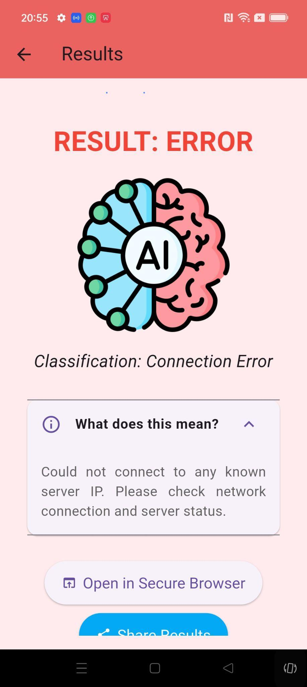

SafeQR will show an error in an event if the QR code scan is not recognisable or the link from the QR code is not valid.

2.3.4 Share Result, Secure Browser and Report this Scan

**Share Result**

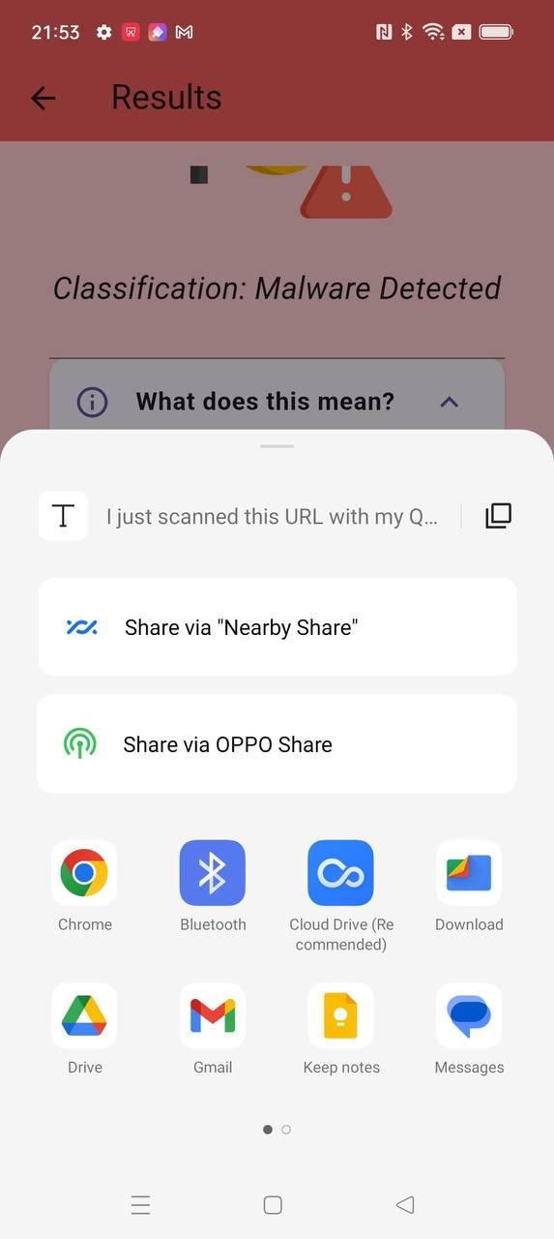

This allows users to share scan results to other users to warn them about potential malicious links

**Open in Secure Browser**

The secure browser allows Users to open potential malicious links through our secure browser to prevent the malicious link from doing harm to their personal devices.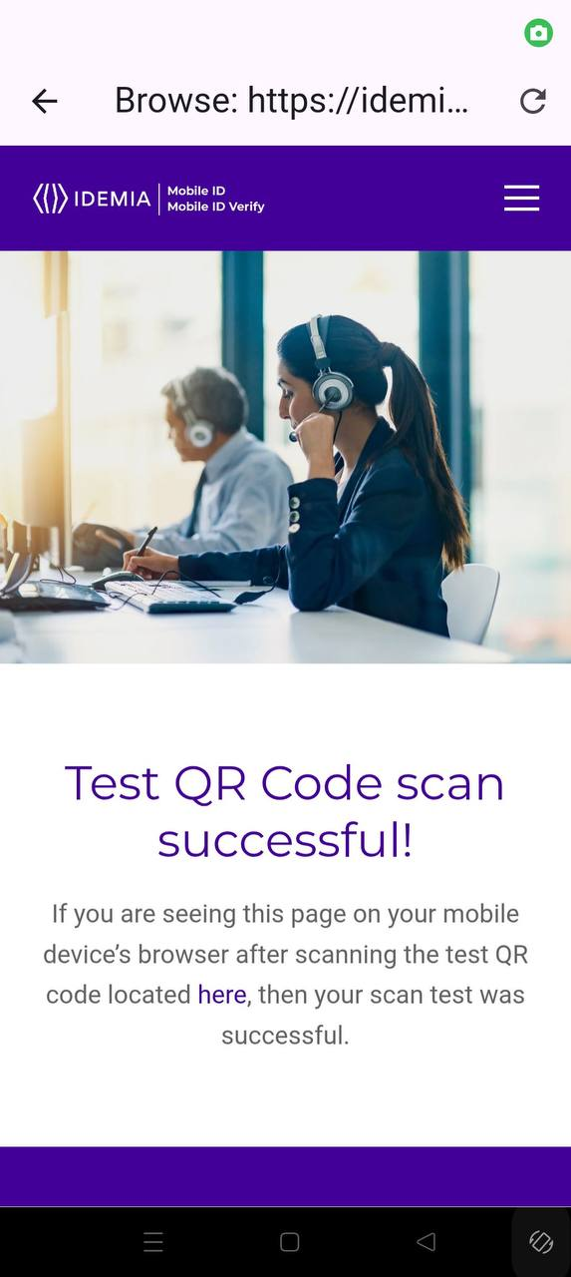

**Report this Scan**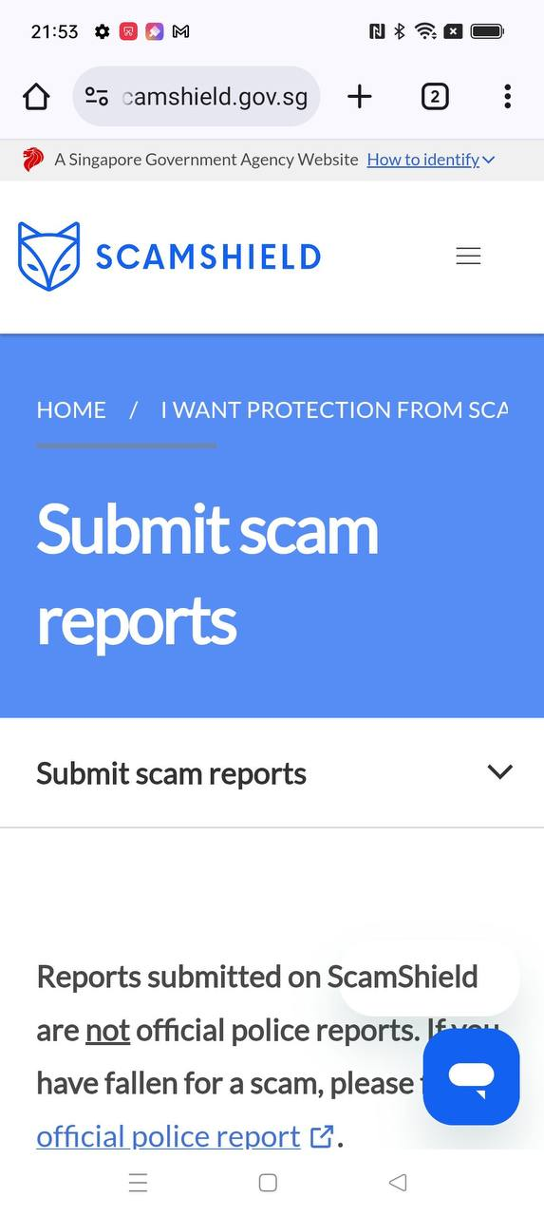

The “Report This Scan” option allows the malicious links to be sent to Scamshield for actions to be taken by official parties.

2.4 Settings

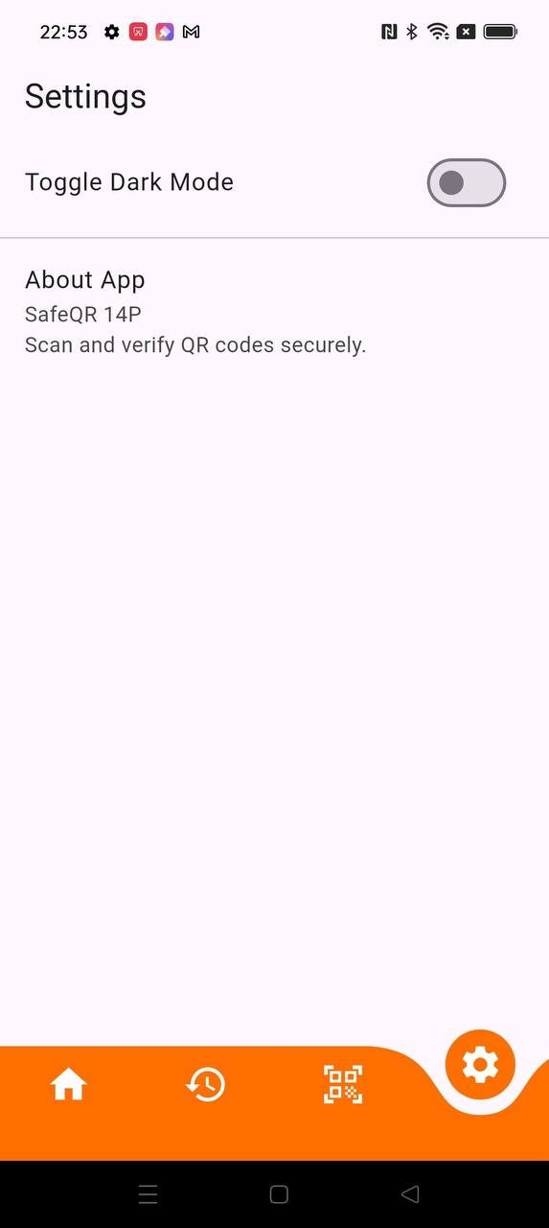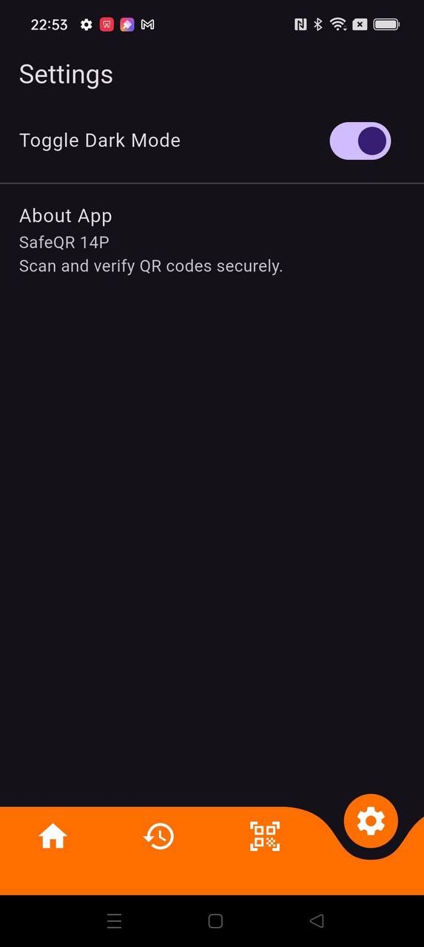

In the “Settings” page, users can have the option to toggle to Dark Mode for a more eye-pleasing view for usage in low lighting conditions. Users can also view the App version here to ensure they have the most updated version.